Supporting Information for:
Long-Term Monitoring of Water and Air Quality at an Indoor Pool Facility During Modifications of Water Treatment
Lester Lee ¹ and Ernest R. Blatchley III ^{1,2,}*
¹Lyles School of Civil Engineering, Purdue University, West Lafayette, Indiana, U.S.
²Division of Environmental and Ecological Engineering, Purdue University, West Lafayette, Indiana, U.S.
*Correspondence: blatch@purdue.edu

Table S1. Source water quality analysis.
Parameter | Reported Value
pH | 7.4
Alkalinity | 274 mg/L as CaCO₃
Fluoride | 0.7 mg/L
Orthophosphate | 0.5 mg/L
Free Ammonia | 0.09 mg/L
Nitrate | 1.1 mg/L
Nitrite | 0.009 mg/L
Sulfate | 70 mg/L
Calcium | 300 mg/L as CaCO₃
Magnesium | 124 mg/L as CaCO₃
Hardness | 424 mg/L as CaCO₃

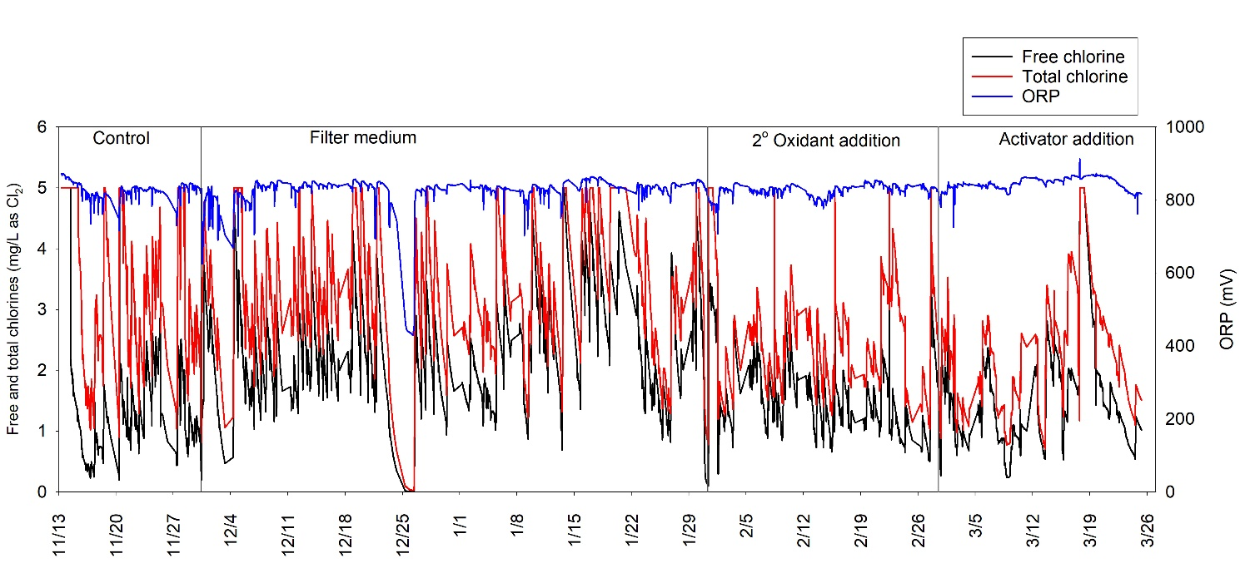
Figure S1. Time-course monitoring of free chlorine, total chlorine and ORP at the studied pool facility.

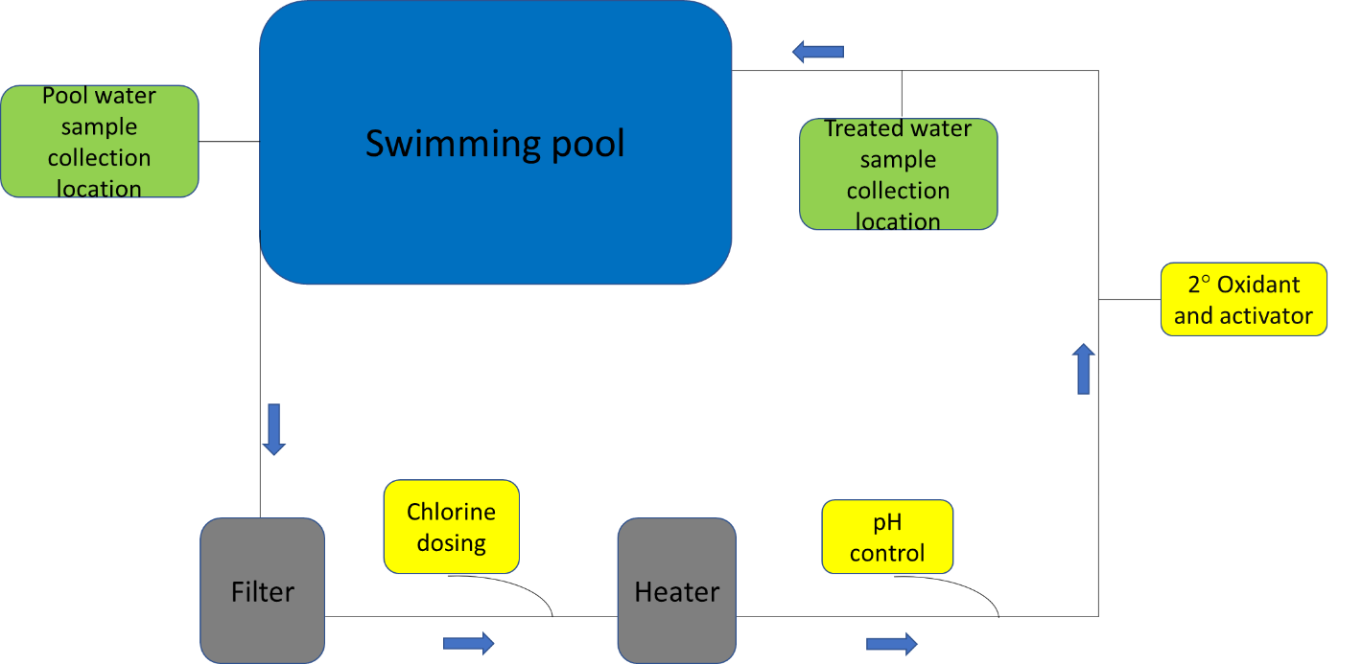
Figure S2. Schematic of pool water treatment process sequence with chemical dosing points and locations of pool water sampling locations.

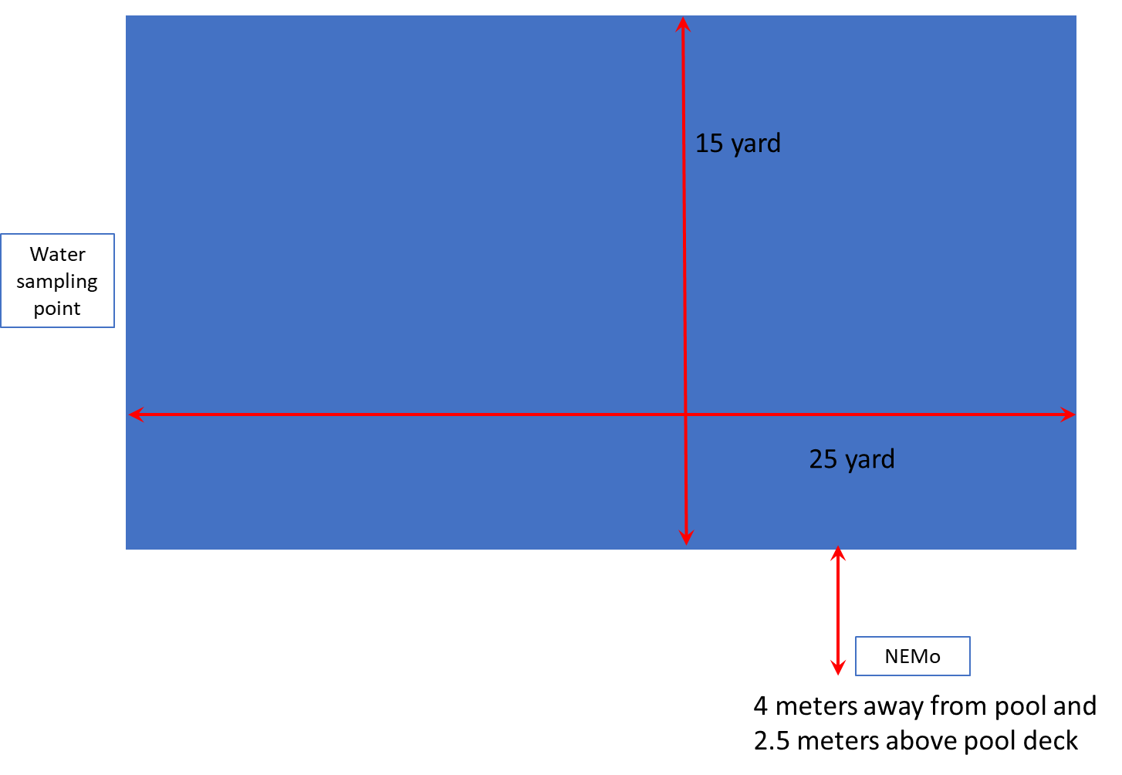
Figure S3. Water sampling and NEMo locations in the studied pool facility. Water samples were collected from roughly 20 cm below the water surface.

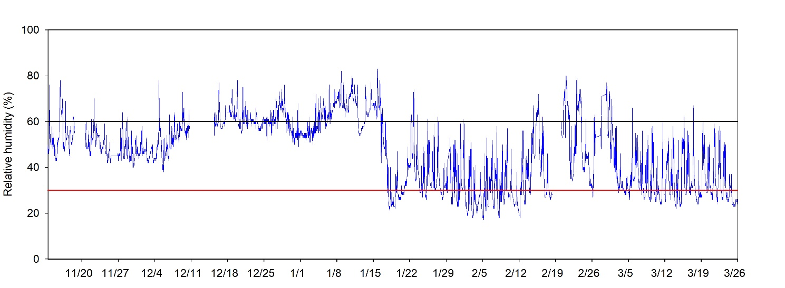
Figure S4. Time-course monitoring of Relative Humidity (RH) at the studied pool facility. Blue line represents the RH measurements. Black horizontal line represents the 60% threshold and red horizontal line represents the 30% threshold.

